INVENTION DISCLOSURE FORM
Confidential & Attorney-Client Privileged
Applicant Name: SR University
SR University, Ananthsagar, Hasanparthy (M), Warangal Urban, Telangana - 506371

1. Particulars of Inventors
Title | Name (Full) | Department | Designation | Mobile No. | Email | Postal Address
Mr. | Naresh Kumar Sripada | CS & AI | Asst. Professor | 9866000203 | Naresh22.in@gmail.com | SR University, Ananthsagar, Hanamkonda
Mr. | Kola Kishore | CS & AI | Student | 8985277570 | kolokishore@gmail.com | SR University, Ananthsagar, Hanamkonda
Mr | Palabindala  Revanth | CS & AI | Student | 9110564538 | revanth.p037@gmail.com | SR University, Ananthsagar, Hanamkonda
Mr. | Kommireddy RupaasShyni | CS & AI | Student | 9014972103 | rupaasshyni@gmail.com | SR University, Ananthsagar, Hanamkonda
Mr. | Pedditi Ruthwick Reddy | CS & AI | Student | 9951776375 | Ruthwickreddy_05@gmail.com | SR University, Ananthsagar, Hanamkonda

2. Provide a brief descriptive title of the invention:
Adaptive Gaze-Contingent Rendering System for Real-Time Visual Focus Adjustment in VR/AR Environments. The invention relates to a system that dynamically adjusts visual rendering based on the user’s eye gaze in real time. By integrating high-speed eye tracking with adaptive optics or rendering techniques, the system aligns visual focus with the user’s point of attention, improving clarity, reducing eye strain, and enhancing overall experience in virtual and augmented reality environments

3. In 100 words or less, please provide an abstract or summary of the invention:
The invention discloses an adaptive gaze-contingent rendering system for mitigating Vergence-Accommodation Conflict (VAC) in virtual and augmented reality environments. It integrates high-speed eye tracking, predictive algorithms, and a varifocal lens system to dynamically align the focal plane with the user’s gaze in real time. The system incorporates neural-intent prediction, foveated rendering, and personalized visual comfort profiling to enhance performance and responsiveness. By achieving sub-5ms latency in focal adjustment, the invention reduces eye strain, improves visual clarity, and enhances immersive experience across VR, AR, and advanced simulation applications

4. Detail Description of the Invention:
(Answer to all below are required in detail)

- Problem the Invention is Solving

Current VR/AR systems suffer from Vergence-Accommodation Conflict (VAC), where the eyes focus at a fixed depth while perceiving varying virtual depths. This mismatch causes eye strain, fatigue, nausea, and reduced immersion. Existing solutions rely on software-based blur techniques that do not physically adjust focal depth. There is no integrated system that dynamically aligns the focal plane with real-time gaze.

b. General Utility / Application of the Invention

The present invention can be used in several domains where immersive visual systems and human-computer interaction are important.
• Virtual Reality (VR): Enhances visual comfort and realism by dynamically adjusting focal depth.
• Augmented Reality (AR): Improves depth perception and reduces eye strain in AR glasses and headsets.
• Medical Applications: Supports surgical visualization and training simulations requiring precise depth accuracy.
• Gaming: Provides immersive and fatigue-free gaming experiences over extended durations.
• Training & Simulation: Useful in aviation, defense, and industrial training systems for realistic environments.
• Education: Enables better engagement in virtual classrooms and interactive learning platforms.
• Industrial Design & Engineering: Assists in 3D modeling and visualization with improved focus accuracy.
Thus, the invention has applications in entertainment, healthcare, education, and advanced simulation environments
.

- Advantages of the Invention

The invention offers several advantages over traditional VR/AR display and rendering systems.
• Eliminates Vergence-Accommodation Conflict (VAC) at the physiological level.
• Provides real-time focal adjustment with ultra-low latency (<5ms).
• Reduces eye strain, fatigue, and motion sickness during prolonged usage.
• Enhances visual clarity and depth perception in immersive environments.
• Uses predictive gaze tracking for faster and smoother rendering.
• Improves computational efficiency through foveated rendering techniques.
• Supports personalized visual comfort using adaptive user profiling.
• Enables integration with multiple XR platforms via a modular design.
• Scalable architecture allows future upgrades with advanced sensors and algorithms.
These advantages make the proposed system more effective than existing VR/AR display technologies
.

d. Best Way of Using the Invention as well as Possible Variants

Best Mode Implementation

Hardware:
• VR/AR headset with integrated high-speed eye-tracking cameras
• Varifocal liquid lens assembly
• Acoustic-piston or piezoelectric actuator for focal adjustment
• Infrared LED illumination system for gaze detection
• Processing unit (on-device or external compute module)

Software:
• Real-time gaze tracking algorithms
• Predictive latency correction algorithms
• Foveated rendering engine
• Neural-intent processing module (EEG/bio-acoustic integration)
• XR rendering frameworks (OpenXR / Unity / Unreal Engine)
Working Method:
• Capture real-time eye gaze using high-speed cameras
• Compute vergence and focal depth
• Predict next gaze position using latency algorithms
• Adjust varifocal lens dynamically (<5ms response)
• Apply foveated rendering based on gaze focus
• Update visual output in real time for improved clarity and comfort

Possible Variants
• Integration into lightweight AR glasses
• Software-assisted mode without hardware lens adjustment
• Cloud-based gaze analytics and optimization
• Addition of advanced neural sensors for intent prediction
• Custom user profiles for adaptive comfort settings
• Compatibility with third-party XR devices via universal interface

e. Working of Invention along with Drawings, Schematics and Flow Diagrams
The invention works in the following stages:

Step 1 – Gaze Data Acquisition:
The system captures real-time eye movement data using high-speed dual cameras and infrared illumination embedded within the VR/AR headset. The captured data includes gaze direction, pupil position, and eye movement dynamics.

Step 2 – Preprocessing and Feature Extraction (Figure 3 & Figure 4):
The raw gaze data is processed to remove noise and extract meaningful features such as gaze vectors, fixation points, and saccadic movements. Binocular disparity is calculated to determine vergence depth.

Step 3 – Depth Estimation and Tracking (Figure 2 & Figure 5):
The system computes the 3D intersection of both eye gaze vectors to estimate the user’s focal depth in real time. Continuous tracking ensures accurate depth updates during eye movement.

Step 4 – Predictive Latency Processing (Figure 6):
A predictive algorithm analyzes gaze patterns and anticipates the next fixation point. This reduces latency by preparing the system for focal adjustment before the actual eye movement occurs.

Step 5 – Varifocal Lens Adjustment (Figure 1 & Figure 7):
The varifocal liquid lens and actuator dynamically adjust the focal plane based on predicted depth. The system achieves sub-5ms response time using acoustic or piezoelectric actuation.

Step 6 – Gaze-Based Foveated Rendering (Figure 8 & Figure 9):
The rendering engine divides the display into foveal and peripheral regions. High-resolution rendering is applied to the gaze focus area, while lower resolution is applied to peripheral regions to optimize performance.

Step 7 – Neural-Intent Integration (Figure 10 & Figure 14):
Optional neural and bio-acoustic inputs are processed to predict user intent before gaze movement, enabling pre-activation of the varifocal system for faster response.

Step 8 – Visual Comfort Optimization (Figure 11):
A Visual Comfort Profile (VCP) continuously adapts system parameters based on user-specific eye behavior, minimizing fatigue and improving long-term usability.
Step 9 – Output Rendering and Display:
The adjusted focal plane and optimized rendering are displayed in real time, providing a natural, immersive, and comfortable viewing experience without Vergence-Accommodation Conflict
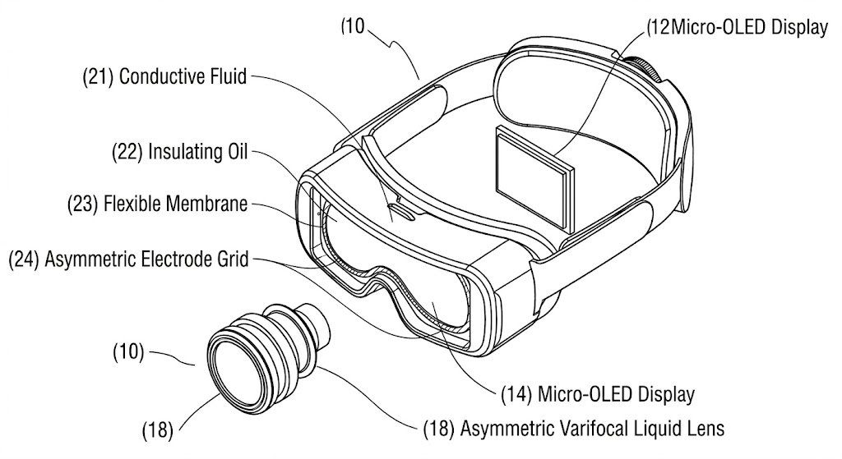
FIG. 1 – Asymmetric Varifocal Liquid Lens & Headset Architecture (Component View)

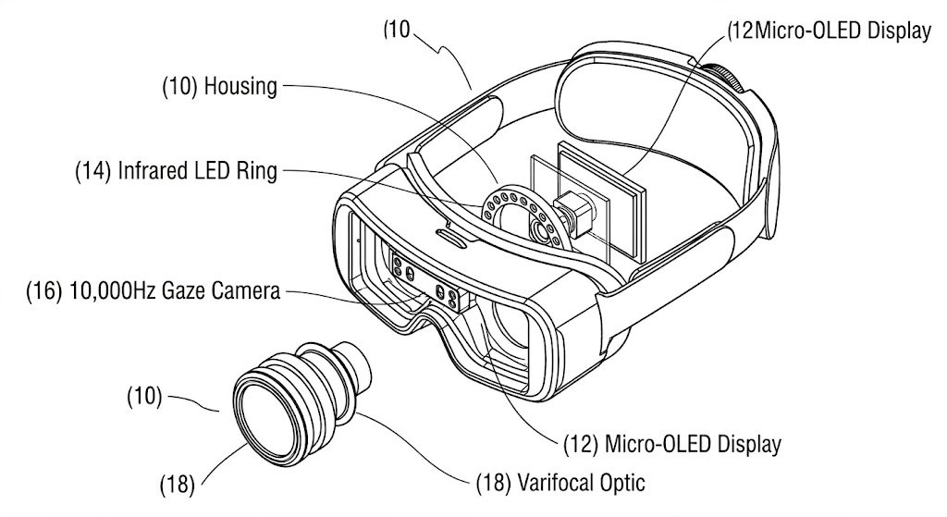
FIG. 2 – Adaptive Headset Architecture with Infrared LED Ring & Gaze Camera

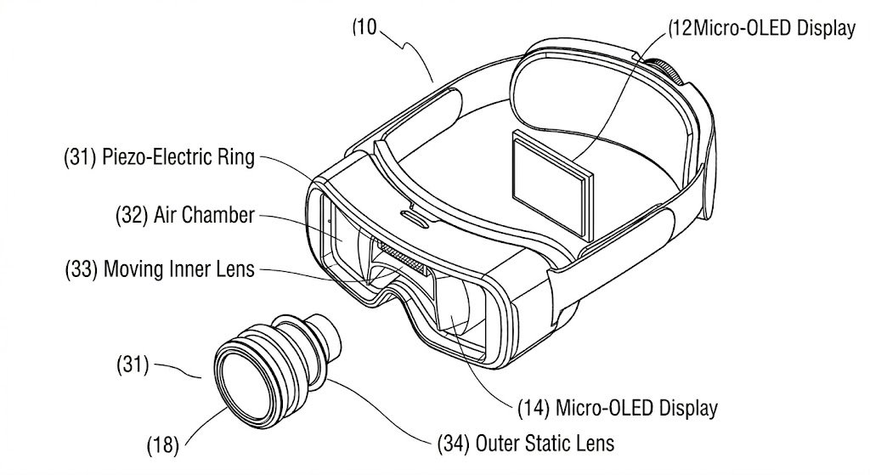
FIG. 3 – Acoustic-Piston Varifocal Actuator (Piezo-Electric Ring Assembly)

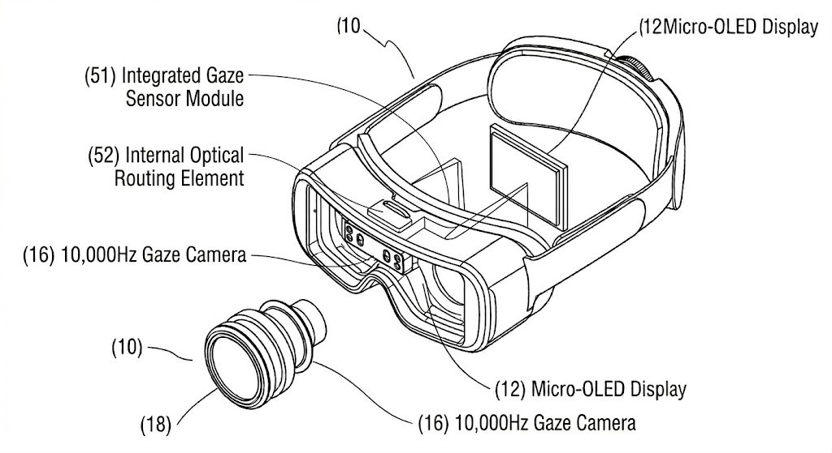
FIG. 4 – Dual-Camera 10,000Hz Tracking Path with Integrated Gaze Sensor Module

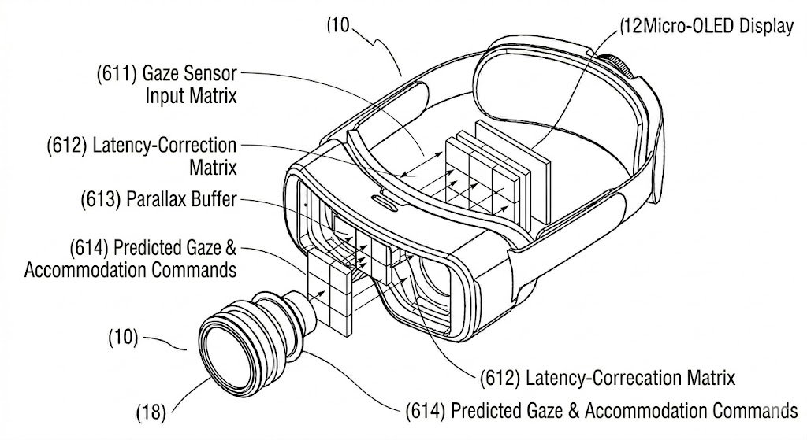
FIG. 5 – Predictive Look-Ahead Latency Algorithm Matrix (Latency-Correction Matrix)

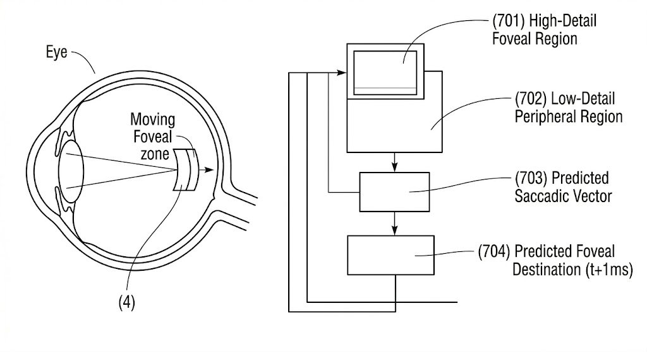
FIG. 6 – Gaze-Aware Foveated Mesh Simplification Levels (Eye Anatomy & Foveal Zone)
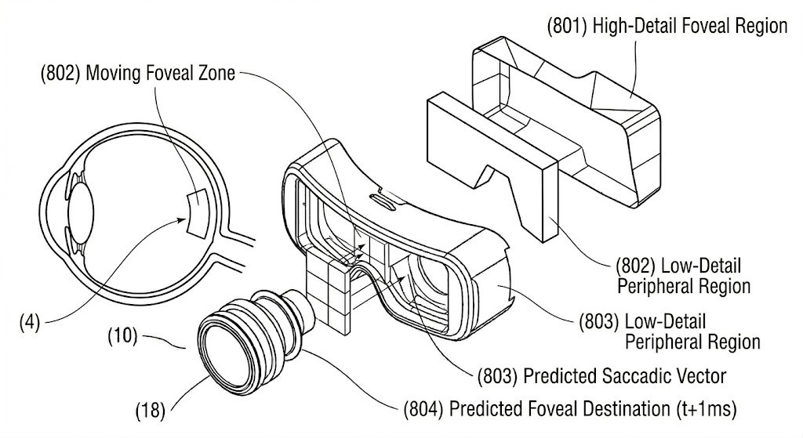
FIG. 7 – Gaze-Aware Foveated Mesh 3D Representation (Saccadic Vector Prediction)
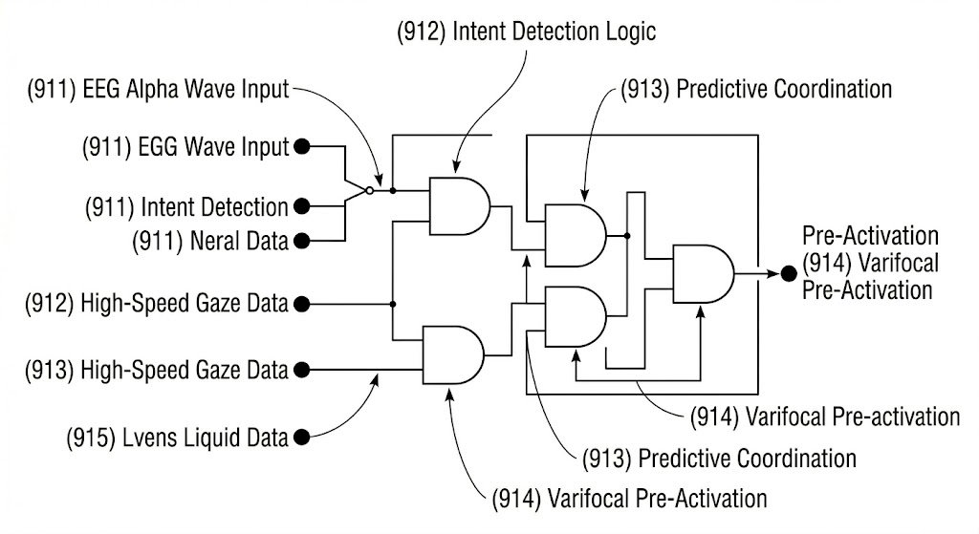
FIG. 8 – Neural-Intent Trigger Mechanism Logic Circuit (EEG/Neural Input Processing)
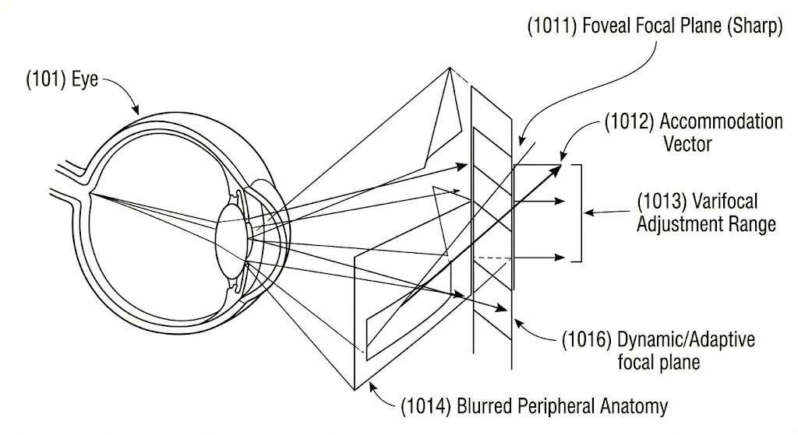
FIG. 9 – Foveal Focal Plane and Accommodation Vector Diagram
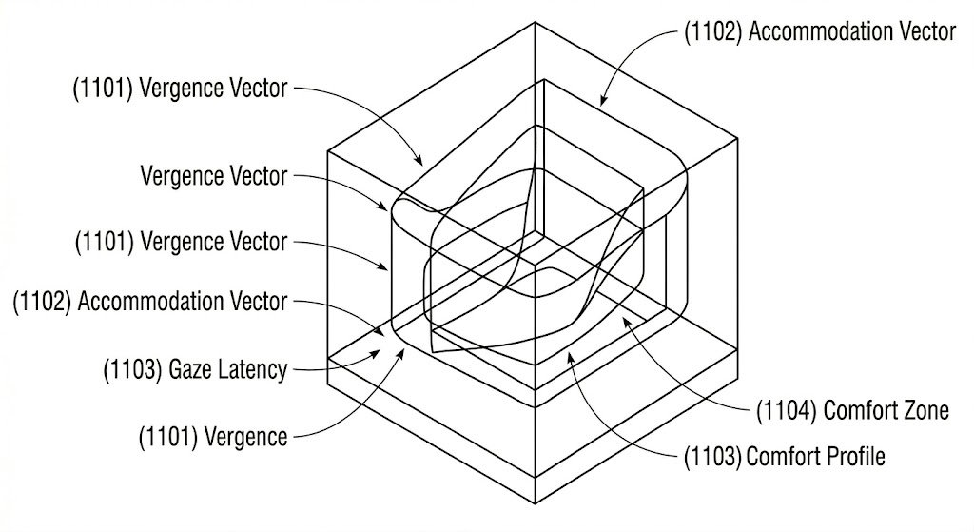
FIG. 10 – Visual Comfort Profile (VCP) 3D Data Map (Vergence-Accommodation Axes)
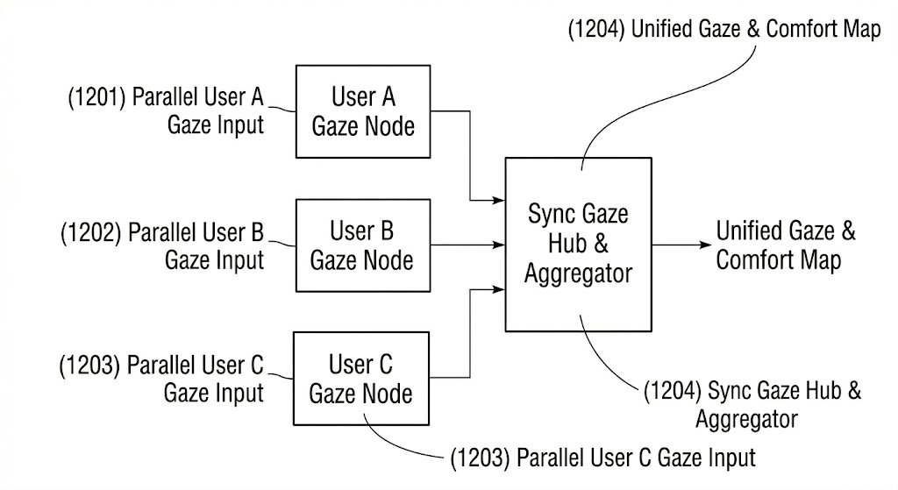
FIG. 11 – Collaborative Multi-User Gaze Mapping Network Architecture
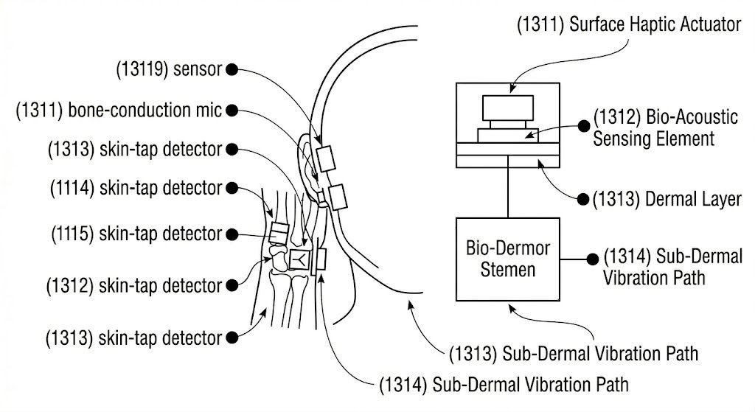
FIG. 12 – Bio-Acoustic Sensor Placement on Human Anatomy (Skin-Tap Detectors)
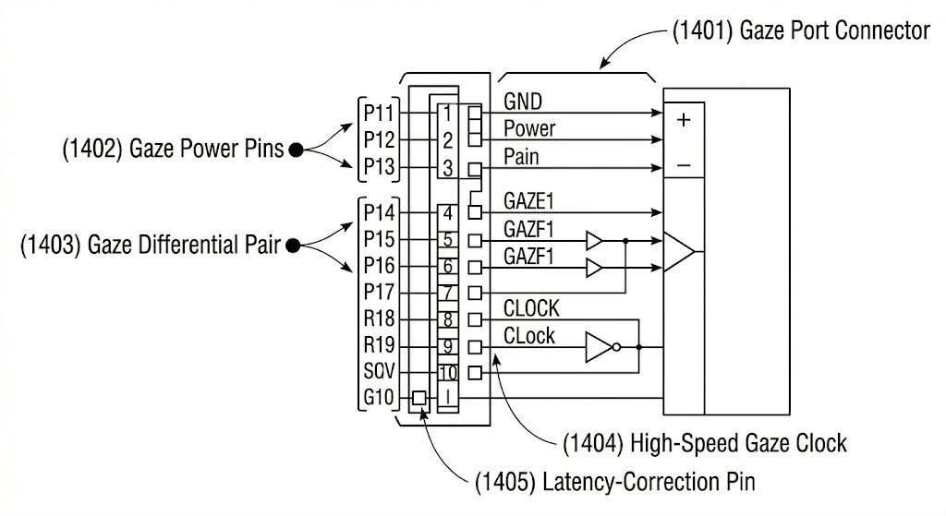
FIG. 13 – MGAD Universal Data Port Interface Schematic (Gaze Port Connector)
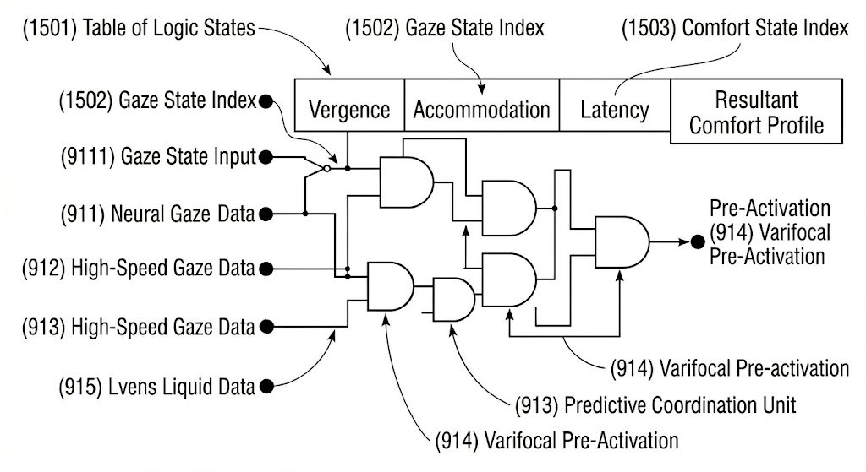
FIG. 14 – Thermal-Throttling Sensor Control Logic & Neural Gaze State Table

5. Primary Patent Search
A primary patent search has been conducted. Relevant prior art was reviewed from patent databases such as USPTO, EPO, and Google Patents related to gaze tracking, varifocal display systems, and VR/AR rendering technologies. Existing solutions primarily focus on software-based depth-of-field techniques or basic eye-tracking without dynamic focal plane adjustment. No exact prior art was identified that integrates high-speed gaze tracking, predictive latency algorithms, neural-intent processing, and real-time varifocal lens adjustment to mitigate Vergence-Accommodation Conflict (VAC). The search indicates that the proposed invention presents a novel and integrated approach. A detailed search report will be attached separately.

6. Existing State-of-the-Art and Prior Art
• Fixed focal plane VR systems: Most existing VR headsets display content at a constant focal depth, causing mismatch between vergence and accommodation.
• Software-based depth-of-field techniques: Methods such as blur rendering simulate focus but do not physically adjust the focal plane, failing to resolve VAC.
• Basic eye-tracking systems: Existing solutions track gaze for interaction but do not integrate dynamic focal adjustment or predictive processing.
• Static varifocal prototypes: Some experimental systems adjust focal depth but lack real-time response, predictive algorithms, or user-specific adaptation.
• Standalone rendering optimizations: Foveated rendering improves performance but does not address physiological visual discomfort or focal mismatch

7. Comparison with Existing Systems

S.No. | Existing System | Drawbacks | How Our Invention Overcomes It
1 | Fixed Focal Plane VR Systems | Causes Vergence-Accommodation Conflict (VAC), leading to eye strain and discomfort | Dynamically adjusts focal plane in real time to match user gaze
2 | Software-Based Depth-of-Field Techniques | Simulates focus using blur; does not physically correct focal mismatch | Uses varifocal lens system for real physical focal adjustmen
3 | Basic Eye-Tracking Systems | Only tracks gaze for interaction; no depth alignment or prediction | Integrates gaze tracking with depth estimation and predictive processing
4 | Static Varifocal Systems | Limited speed and lacks real-time responsiveness | Achieves sub-5ms focal adjustment using advanced actuators

8. Technical Features and Elements of the Invention
- High-speed gaze tracking module: dual-camera system operating at ~10,000Hz for precise eye movement detection.
- Infrared illumination system: integrated IR LED ring for accurate pupil tracking under varying lighting conditions.
- Binocular vergence computation: calculates 3D focal depth using intersection of both eye gaze vectors.
- Predictive latency algorithm: anticipates gaze shifts using latency-correction matrix and parallax buffering.
- Varifocal liquid lens system: dynamically adjusts focal length using conductive fluid and insulating medium.
- Asymmetric electrode configuration: enables real-time focus adjustment and astigmatism correction.
- Acoustic-piston / piezoelectric actuator: achieves sub-5ms focal plane adjustment.
- Gaze-aware foveated rendering engine: allocates high resolution to foveal region and reduces peripheral detail.
- Neural-intent processing module: integrates EEG and bio-acoustic signals for pre-emptive system response.
- Visual Comfort Profile (VCP): models user-specific comfort parameters across vergence, accommodation, and latency.
- Real-time rendering pipeline: synchronizes gaze input, focal adjustment, and display output.
- Multi-user gaze synchronization module: aggregates gaze data across users for collaborative XR environments.
- Bio-acoustic sensing subsystem: detects ciliary muscle activity using wearable sensors.
- MGAD universal data port: provides standardized interface for interoperability with third-party XR systems.
- Scalable deployment architecture: supports integration in VR headsets, AR glasses, and future XR devices

9. Novel Features of the Invention
- Real-time integration of high-speed gaze tracking with dynamic varifocal lens adjustment.
• Predictive latency algorithm that anticipates gaze shifts before actual eye movement.
• Combination of hardware (varifocal optics) and software (AI-based prediction) for VAC mitigation.
• Neural-intent processing using EEG and bio-acoustic signals for pre-emptive system response.
• Personalized Visual Comfort Profile (VCP) adapting to individual user eye behavior.
• Integration of gaze-aware foveated rendering with focal plane correction.
• Unified system combining sensing, prediction, rendering, and adaptive control in a single framework.

10. Implementation Details
The invention has been conceptually designed and prototyped using the following technical components:
• Hardware: VR/AR headset with eye-tracking cameras and varifocal lens system
• Processing Unit: GPU-enabled computing environment for real-time processing
• Algorithms: Predictive gaze tracking and latency correction models
• Rendering Platform: Unity / Unreal Engine with OpenXR support
• Sensors: Infrared eye-tracking module, optional EEG and bio-acoustic sensors
• Testing Environment: Simulated XR setup for validating focal adjustment and latency

11. Idea Conception
The invention was conceived during research on limitations of existing VR/AR systems, particularly the issue of Vergence-Accommodation Conflict (VAC). It was observed that current solutions fail to physically align focal depth with user gaze. This led to the idea of integrating real-time gaze tracking, predictive processing, and varifocal optics into a unified system..

12. Prior Disclosure
No public sale, offer for sale, or publication related to this invention has been made prior to this submission. The invention has not been disclosed outside the research environment. No non-disclosure agreements were required. There are no known statutory deadlines affecting this filing

13. Non-Obviousness
The invention is non-obvious for the following reasons:
• Existing systems either use software-based blur or basic eye tracking without focal adjustment.
• The integration of predictive gaze algorithms with real-time varifocal optics is not present in prior art.
• The inclusion of neural-intent signals for pre-emptive system response introduces a novel approach.
• The combination of hardware and software modules into a unified adaptive rendering system is not obvious from existing technologies.

14. Additional Comments
The invention can be extended in the following directions:
• Advanced eye-health monitoring: Integrate long-term tracking of eye strain, fatigue, and visual behavior patterns.
• AI-driven adaptive rendering: Use machine learning to further optimize focal adjustment and rendering based on user habits.
• Lightweight wearable integration: Extend the system to compact AR glasses and next-generation wearable XR devices.
• Collaborative XR environments: Enable synchronized gaze-based rendering across multiple users in shared virtual spaces.
• Medical and surgical applications: Apply the system in precision visualization systems requiring accurate depth perception.
• Cloud-assisted optimization: Use cloud-based processing for enhanced prediction and system calibration.
• Enterprise and training systems: Deploy in industrial simulations, defense training, and remote collaboration platforms

15.Flow Chart / Table of Contents of All Diagrams
Figure | Title | Description
Fig. 1 | High-Level System Architecture | Overall structure of gaze tracking, processing unit, varifocal system, and display
Fig. 2 | Gaze Detection System | Eye-tracking using dual cameras and infrared illumination
Fig. 3 | Gaze Data Preprocessing | Noise filtering, feature extraction, and gaze vector computation
Fig. 4 | Vergence Depth Estimation | Noise filtering, feature extraction, and gaze vector computation
Fig. 5 | Predictive Latency Algorithm | Anticipation of gaze movement using latency correction models
Fig. 6 | Varifocal Lens System | Dynamic focal adjustment using liquid lens technology
Fig. 7 | Actuator Mechanism | Acoustic/piezoelectric control for fast lens adjustment
Fig. 8 | Foveated Rendering Engine | Allocation of high detail to foveal region and reduced detail to periphery
Fig. 9 | Rendering Pipeline | Integration of gaze input with real-time display output
Fig. 10 | Neural-Intent Processing | EEG and bio-acoustic signal integration for predictive response
Fig. 11 | Visual Comfort Profile (VCP) | User-specific comfort mapping across gaze and focus parameters
Fig. 12 | Bio-Acoustic Sensor Layout | Placement of wearable sensors for physiological signal capture
Fig. 13 | MGAD Data Port Interface | Standardized interface for device interoperability
Fig. 14 | System Control Logic | Decision-making and coordination between modules
Fig. 15 | Overall System Workflow | End-to-end working of the adaptive gaze system

